Name: | ___________________________________________________ |  |  |  |  | Date: ___________
 | Year 9 Ace/Maritime/General Mathematics  Investigation 5, 2015  Topic – Transformation of Quadratic Equations  In Class Component |  |  |  |  | 47  = %
Total Time: | 60 minutes |  | Reading Time: | 5 minutes
Working Time: | 55 minutes
Equipment: | Take Home Component  Calculator | AIM: In this assessment, you will be investigating the transformation of Quadratic Equations.
1. | [10 marks; 2, 2, 3, 3]
a) | Complete the table of values for the equations shown.
 | -5 | -4 | -3 | -2 | -  1 | 0 | 1 | 2 | 3 | 4 | 5
 | -1 | 0 | 1 | 2 | 3 | 4 | 5 | 6 | 7 | 8 | 9

b) | Draw each of these equations on the axis below, be sure to label each function.
 | 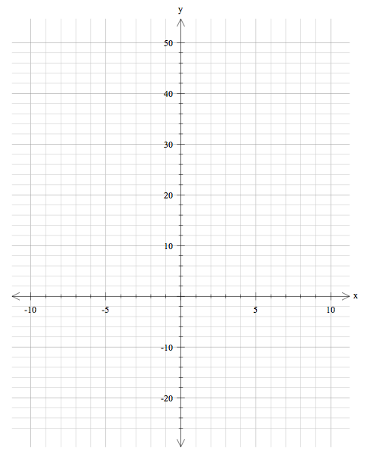
2. | [10 marks; 2, 2, 3, 3]
a) | Complete the table of values for the equations shown.
 | 0 | 1 | 2 | 3 | 4 | 5 | 6 | 7 | 8
 | -9 | -8 | -7 | -6 | -5 | -4 | -3 | -2 | -1

b) | Draw each of these equations on the axis below, be sure to label each function.
 | 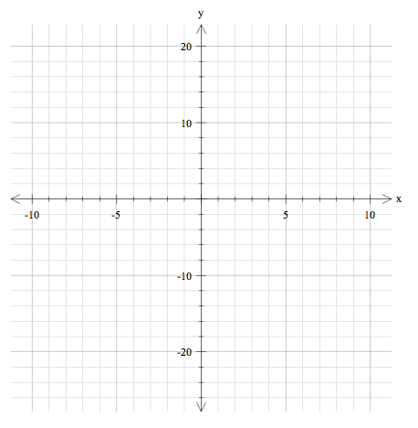

Transformation Terminology
Dilation
This is when the graph is thinner (closer to the y-axis) or is wider (closer to the x-axis).
Reflection
This is when the graph has been reflected or flipped over the x-axis.
Vertical Translation
This is when the graph has been moved or translated up or down a specific number of units.
Horizontal Translation
This is when the graph has been moved or translated left or right a specific number of units.
 | [15 marks; 1, 2, 3, 5, 4]
3. | Using the terminology above describe how the original graph $y=x^{2}$ changes the following equations:
a)
b)
c)
d)
e)
 | [3 marks; 1, 1, 1]
4. | Choose the correct equation that matches each graph:  a)  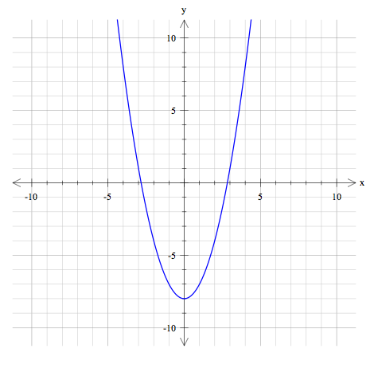  b)  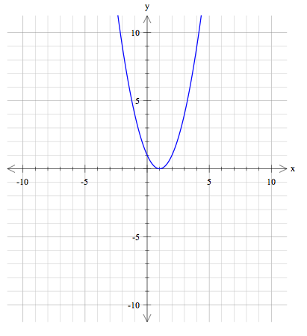  c)  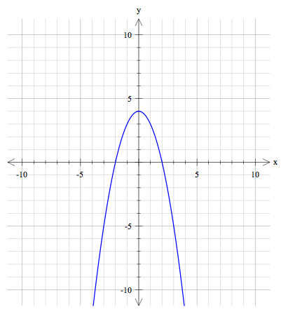
 | [3 marks; 1, 1, 1]
5. | Choose the correct equation that matches each graph:  a)  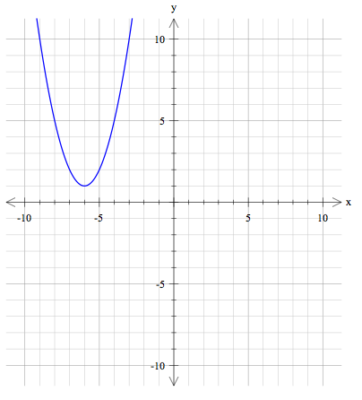  b)  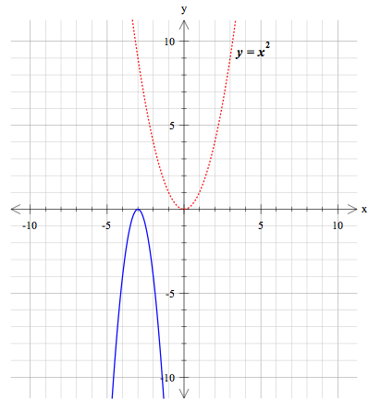  c)  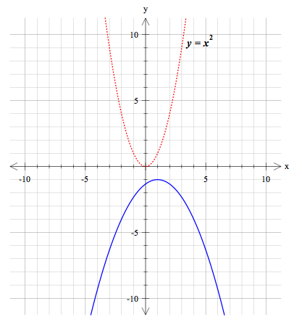
6. | [4 marks; 2, 2]
 | Using the information you have discovered about transforming quadratics write the equation for each of the following quadratic graphs. Please note there has been no dilation.
a) | b)
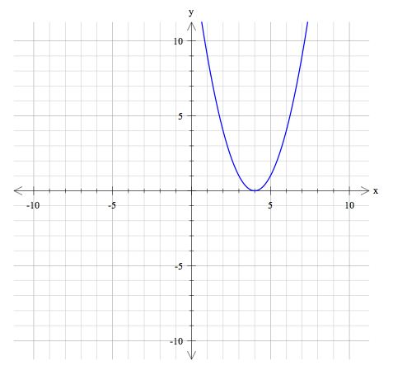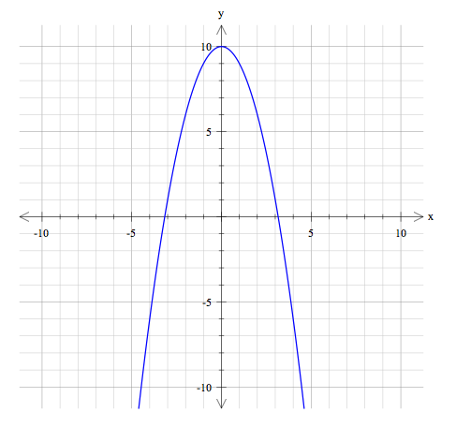

7. | [2 marks]
 | Draw a sketch of the following quadratic given the equations below:
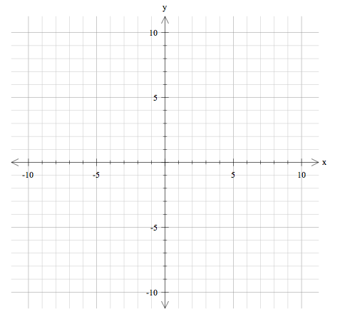
END OF TEST

